**Task 1**

Description:

Creating a simple calculator in C programming using the

If selection statement,

switch Multiple selection statement,

while iteration Statement,

Counter Control iteration,

This program takes an arithmetic operator +, -, *, / and two operands from the user. Then, it performs the calculation on the two operands depending upon the operator entered by the user.

The * operator entered by the user is stored in op. And, the two operands, 1.5 and 4.5 are stored in first and second respectively.

Since the operator * matches case '*':, the control of the program jumps to

printf("%.1lf * %.1lf = %.1lf", first, second, first * second);

This statement calculates the product and displays it on the screen.

To make our output look cleaner, we have simply limited the output to one decimal place using the code %.1lf.

Finally, the break; statement ends the switch statement

**Code:**

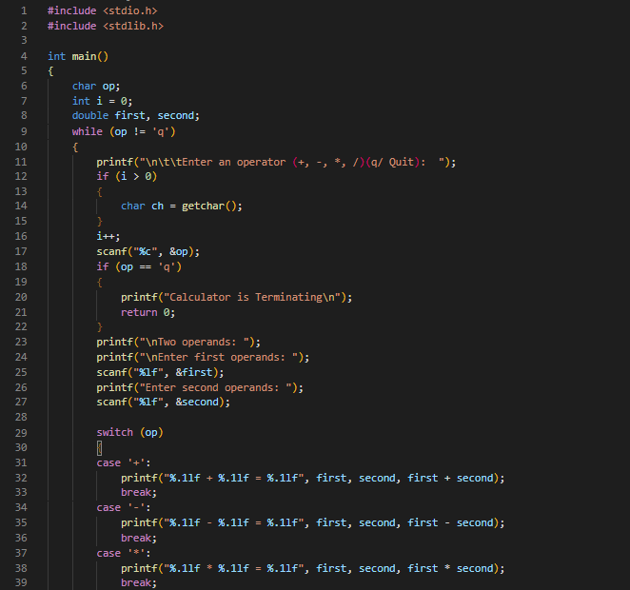

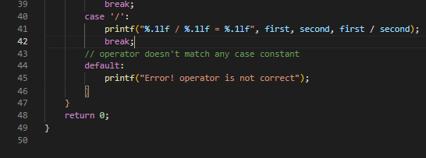

**Output:**

